1st September
Class 5 | Maths

Durga, Sowmya and Sudarshan have drawn the following shapes.

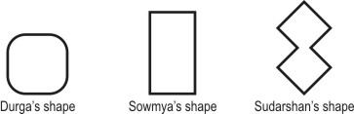

Who has drawn a shape having only STRAIGHT lines?

A. only Sowmya
B. only Durga and Sowmya
C. only Sowmya and Sudarshan
D. all- Durga, Sowmya and Sudarshan
Yesterday's Question | Class 5 | Science
Fish have fins; in the same way, birds have _____
A. beaks | B. lungs
C. feathers | D. gills

Correct Answer : C

2nd September
Class 5 | Science
Which of these is caused by drinking unclean water?
A. Malaria
B. Typhoid
C. Chicken pox
D. Measles
Yesterday's Question | Class 5 | Maths

Durga, Sowmya and Sudarshan have drawn the following shapes.

Who has drawn a shape having only STRAIGHT lines?

A. only Sowmya | B. only Durga and Sowmya
C. only Sowmya and Sudarshan | D. all- Durga, Sowmya and Sudarshan

Correct Answer : C

5th September
Class 5 | English
Neena: Good! Can you come to my house this afternoon?
Sunil: ___________________________________
A. Yes, you can.
B. Okay. I'm waiting for you.
C. Yes, I don't know.
D. Yes, I'll come.
Saturday's Question | Class 5 | Social Studies
You want to gain a better understanding of the history of ancient Egypt. Which of these buildings would you choose to study?
A. 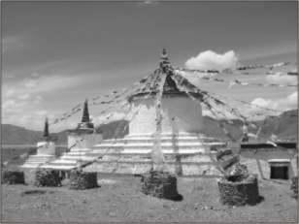 | B. 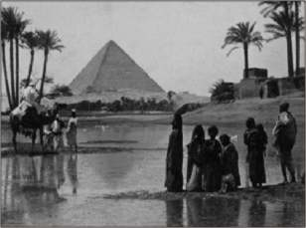
C. 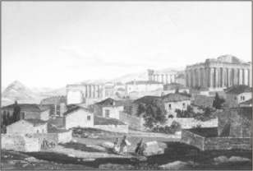 | D. 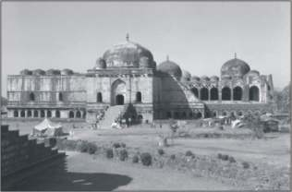

Correct Answer : B

6th September

Class 5 | Maths
The number 10 has 4 factors - 1, 2, 5 and 10.
The table below lists the NUMBER OF FACTORS for some numbers.
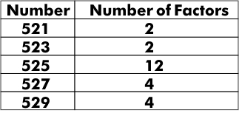
From this we can say that the number of prime numbers between 520 and 530 is:
A. 0
B. 2
C. 4
D. cannot be said for sure.
Yesterday's Question | Class 5 | English
Neena: Good! Can you come to my house this afternoon?
Sunil: ___________________________________
A. Yes, you can. | B. Okay. I'm waiting for you.
C. Yes, I don't know. | D. Yes, I'll come.

Correct Answer : D

7th September
Class 5 | Science
The set up shows an apparatus for filtration. This apparatus can be used for separating which of the following mixtures?
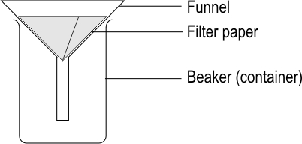
A. salt and sugar
B. sugar and water
C. glucose and water
D. saw dust and water
Yesterday's Question | Class 5 | Maths
The number 10 has 4 factors - 1, 2, 5 and 10.
The table below lists the NUMBER OF FACTORS for some numbers.
From this we can say that the number of prime numbers between 520 and 530 is:
A. 0 | B. 2
C. 4 | D. cannot be said for sure.

Correct Answer : B

8th September
Class 5 | Maths

Look at the following cartoon strip. A mother and a son are talking to each other.

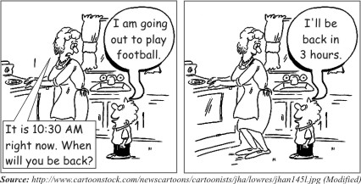

By what time is the son likely to come back home?
A. 7:30 AM
B. 7:30 PM
C. 1:30 AM
D. 1:30 PM
Yesterday's Question | Class 5 | Science
The set up shows an apparatus for filtration. This apparatus can be used for separating which of the following mixtures?
A. salt and sugar | B. sugar and water
C. glucose and water | D. saw dust and water

Correct Answer : D

9th September
Class 5 | Science
In which of these situations is the soil most likely to be blown away by the wind?
A. where annual rainfall is high
B. where the land is covered with grass
C. where the land is covered by forests
D. where annual rainfall is low
Yesterday's Question | Class 5 | Maths

Look at the following cartoon strip. A mother and a son are talking to each other.

By what time is the son likely to come back home?

A. 7:30 AM | B. 7:30 PM
C. 1:30 AM | D. 1:30 PM

Correct Answer : D

12th September

Class 5 | English
In which of the following words is the sound of the FIRST LETTER the SAME as it is in ''kitten''?
A. cease
B. castle
C. cycle
D. circular
Saturday's Question | Class 5 | Social Studies
One of India's major irrigation schemes is 'Nagarjunasagar', on the River Krishna. Which of the following states directly benefits from this irrigation scheme?
A. Andhra Pradesh | B. Madhya Pradesh
C. Gujarat | D. Kerala

Correct Answer : A

13th September
Class 5 | Maths
Arti bought ½ kilogram of sweets. How many grams did she buy?
A. 200 grams
B. 250 grams
C. 500 grams
D. 1000 grams
Yesterday's Question | Class 5 | English
In which of the following words is the sound of the FIRST LETTER the SAME as it is in ''kitten''?
A. cease | B. castle
C. cycle | D. circular

Correct Answer : B

14th September

Class 5 | Science
A dry, empty glass is carefully inverted into a vessel of water without tilting. Which of these figures correctly shows the level of water in the inverted glass?
A. 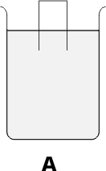 | B. 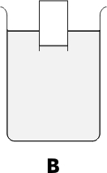
C. 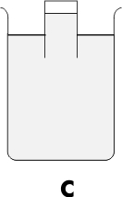 | D. 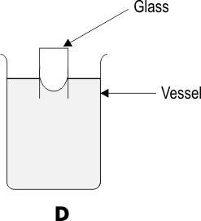

Yesterday's Question | Class 5 | Maths
Arti bought ½ kilogram of sweets. How many grams did she buy?
A. 200 grams | B. 250 grams
C. 500 grams | D. 1000 grams

Correct Answer : C

15th September
Class 5 | Maths

The jar shown alongside can hold 1 litre of water when filled upto the mark shown.

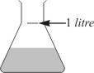

How much water does it contain now?
A. 1/2 litre
B. more than 1/2 litre
C. less than 1/2 litre
D. (We cannot say any of the above.)
Yesterday's Question | Class 5 | Science
A dry, empty glass is carefully inverted into a vessel of water without tilting. Which of these figures correctly shows the level of water in the inverted glass?
A. | B.
C. | D.

Correct Answer : B

16th September
Class 5 | Science
Aquariums often have some water plants kept in them. What is the MAIN reason for this?
A. The plants beautify the aquarium.
B. The plants serve as food for the fish.
C. The plants release oxygen needed by the fish.
D. The plants provide shade and shelter to the fish.
Yesterday's Question | Class 5 | Maths

The jar shown alongside can hold 1 litre of water when filled upto the mark shown.

How much water does it contain now?

A. 1/2 litre | B. more than 1/2 litre
C. less than 1/2 litre | D. (We cannot say any of the above.)

Correct Answer : B

19th September
Class 5 | English
In which of these words does the ''oo'' (double 'o') give us EXACTLY the SAME SOUND as the ''oo'' in ''book''?
A. root
B. boot
C. loot
D. foot
Saturday's Question | Class 5 | Social Studies
Some duties are compulsory for Indian citizens and not performing them may result in punishment by the law. Which of the following is a duty that is COMPULSORY?
A. payment of taxes | B. having a passport
C. holding a bank account | D. voting during the elections

Correct Answer : A
20th September
Class 5 | Maths

If 75 is divided by 8, 9 is the quotient and 3 is the remainder.

What will be the quotient and the remainder when 716 is divided by 7?
A. Quotient = 12, Remainder = 2
B. Quotient = 102, Remainder = 2
C. Quotient = 2, Remainder = 12
D. Quotient = 2, Remainder = 102
Yesterday's Question | Class 5 | English
In which of these words does the ''oo'' (double 'o') give us EXACTLY the SAME SOUND as the ''oo'' in ''book''?
A. root | B. boot
C. loot | D. foot

Correct Answer : D

21st September
Class 5 | Science
Which of these statements is true about the SHADOW of any object?
A. The shadow cannot be larger than the object itself.
B. The shadow cannot lie between the object and the source of light causing it.
C. The shadow always forms on a flat surface.
D. The larger the size of the source of light, the larger the shadow.
Yesterday's Question | Class 5 | Maths

If 75 is divided by 8, 9 is the quotient and 3 is the remainder.

What will be the quotient and the remainder when 716 is divided by 7?

A. Quotient = 12, Remainder = 2 | B. Quotient = 102, Remainder = 2
C. Quotient = 2, Remainder = 12 | D. Quotient = 2, Remainder = 102

Correct Answer : B

22nd September
Class 5 | Maths
An odometer is used to show the distance travelled by a vehicle. Shown here is the odometer of Rohan's scooter..
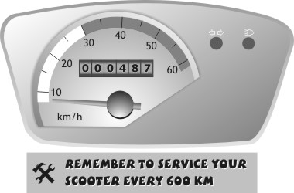
He has travelled 487 km. After travelling for how many more kilometres should he send his scooter for the first service?
A. 113 km
B. 213 km
C. 287 km
D. 1087 km
Yesterday's Question | Class 5 | Science
Which of these statements is true about the SHADOW of any object?
A. The shadow cannot be larger than the object itself. | B. The shadow cannot lie between the object and the source of light causing it.
C. The shadow always forms on a flat surface. | D. The larger the size of the source of light, the larger the shadow.

Correct Answer : B

23rd September
Class 5 | Science
Air pollution is caused by
A. dust only
B. smoke and harmful gases only
C. dust, smoke and harmful gases
D. dust and harmful gases only
Yesterday's Question | Class 5 | Maths
An odometer is used to show the distance travelled by a vehicle. Shown here is the odometer of Rohan's scooter..
He has travelled 487 km. After travelling for how many more kilometres should he send his scooter for the first service?
A. 113 km | B. 213 km
C. 287 km | D. 1087 km

Correct Answer : A

26th September

Class 5 | English

Choose the pair of words with the CORRECT SPELLINGS to complete the sentence MEANINGFULLY.

My brother had a lot of________________ and many _________ to share at the end of his study tour to the north.
A. information - story
B. informations - storeys
C. information - stories
D. informations - stories
Saturday's Question | Class 5 | Social Studies
One of the following Indian traditions adds poisonous substances to the rivers. These substances affect river animals and human health. Identify this tradition.
A. sinking idols into the rivers | B. throwing flowers into the rivers
C. building shrines near the rivers | D. using water from the rivers for irrigation

Correct Answer : A

27th September
Class 5 | Maths

Look at this tile.



Which of these is the same tile?

(Note: the tile may have been turned.)

A. 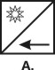 | B. 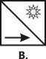
C. 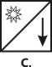 | D. 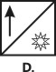

Yesterday's Question | Class 5 | English

Choose the pair of words with the CORRECT SPELLINGS to complete the sentence MEANINGFULLY.

My brother had a lot of________________ and many _________ to share at the end of his study tour to the north.

A. information - story | B. informations - storeys
C. information - stories | D. informations - stories

Correct Answer : C

28th September
Class 5 | Science
Rajeev was asked to make a table with some living things and non-living things. He made the table shown below.
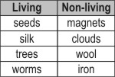
Which of the following has he put under the wrong heading?
A. silk
B. wool
C. seeds
D. worms
Yesterday's Question | Class 5 | Maths

Look at this tile.

Which of these is the same tile?

(Note: the tile may have been turned.)

A. | B.
C. | D.

Correct Answer : A

29th September

Class 5 | Maths

A teacher was playing a game with her students. She drew a circle. Three of her students Aparna, Brinda and Celina stood on it. She stood at the centre of the circle.

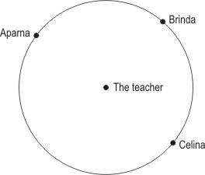

Which of these girls was the farthest from the teacher?
A. Aparna
B. Brinda
C. Celina
D. (All three are at the same distance from the teacher.)
Yesterday's Question | Class 5 | Science
Rajeev was asked to make a table with some living things and non-living things. He made the table shown below.
Which of the following has he put under the wrong heading?
A. silk | B. wool
C. seeds | D. worms

Correct Answer : A

30th September

Class 5 | Science
Look at the information given on a bottle of medicine.
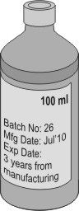
In which of the following months will it be UNSAFE to use this medicine?
A. August 2010
B. October 2010
C. January 2013
D. August 2013
Yesterday's Question | Class 5 | Maths

A teacher was playing a game with her students. She drew a circle. Three of her students Aparna, Brinda and Celina stood on it. She stood at the centre of the circle.

Which of these girls was the farthest from the teacher?

A. Aparna | B. Brinda
C. Celina | D. (All three are at the same distance from the teacher.)

Correct Answer : D

1st August

Class 5 | English
Before which of these words can ''mis-'' be ADDED to FORM a NEW WORD that means to ''have no belief in''?
A. take
B. chief
C. trust
D. behave
Saturday's Question | Class 5 | Social Studies
Which of these places is carved out of a single rock?
A. 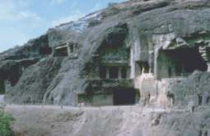 | B. 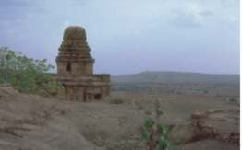
C. 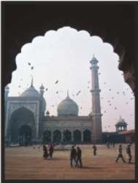 | D. 

Correct Answer : A

2nd August
Class 5 | Maths
What is seven hundreds, plus thirteen tens?
A. 713
B. 7130
C. 830
D. 731
Yesterday's Question | Class 5 | English
Before which of these words can ''mis-'' be ADDED to FORM a NEW WORD that means to ''have no belief in''?
A. take | B. chief
C. trust | D. behave

Correct Answer : C

3rd August
Class 5 | Science
Bindu's teacher asked a few students to perform an experiment described in the textbook. However, Bindu found that her results were different from what was described in the book. What should Bindu do?
A. She should keep repeating the experiment till she gets the result reported in the textbook.
B. She should change the observations so that she gets the result reported in the textbook
C. She should use her friends' observations.
D. She should report her observations the way they are.
Yesterday's Question | Class 5 | Maths
What is seven hundreds, plus thirteen tens?
A. 713 | B. 7130
C. 830 | D. 731

Correct Answer : C

4th August
Class 5 | Maths
A solid object, when seen from one side, looks like this:

The same solid, when viewed from top, looks like this:

Which of these shapes could it be?
A. 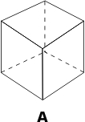 | B. 
C. 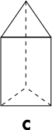 | D. 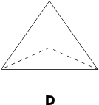

Yesterday's Question | Class 5 | Science
Bindu's teacher asked a few students to perform an experiment described in the textbook. However, Bindu found that her results were different from what was described in the book. What should Bindu do?
A. She should keep repeating the experiment till she gets the result reported in the textbook. | B. She should change the observations so that she gets the result reported in the textbook
C. She should use her friends' observations. | D. She should report her observations the way they are.

Correct Answer : D

5th August
Class 5 | Science
Which option shows the items correctly in the ascending order of their distances from you:
A. Stars, the sun, clouds, the moon, a flying crow.
B. A flying crow, clouds, the moon, the sun, stars.
C. A flying crow, the moon, clouds, stars, the sun.
D. Clouds, a flying crow, the moon, stars, the sun
Yesterday's Question | Class 5 | Maths
A solid object, when seen from one side, looks like this:
The same solid, when viewed from top, looks like this:
Which of these shapes could it be?
A. | B.
C. | D.

Correct Answer : C
8th August
Class 5 | English
Sushmita wanted to arrange the following DVDs in ALPHABETICAL ORDER.
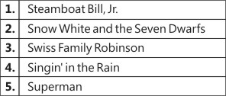
Choose the CORRECT option which arranges these DVDs in ALPHABETICAL ORDER.
A. 5 - 4 - 3 - 2 - 1
B. 2 - 4 - 1 - 3 - 5
C. 1 - 2 - 5 - 3 - 4
D. 4 - 2 - 1 - 5 - 3
Saturday's Question | Class 5 | Social Studies
Where do we commonly find ISBN numbers (as shown in the figure below)?

A. a bank cheque | B. a school identity card
C. the back cover of a book | D. an electricity bill

Correct Answer : C

9th August
Class 5 | Maths
Mr. Frog and Mr. Toad are sitting on a rock. There are many stones in front of them. Mr. Frog can jump 6 stones at a time and Mr. Toad can jump 4 stones at a time. Which is the first stone on which both of them will land, if they jump as far they can each time?
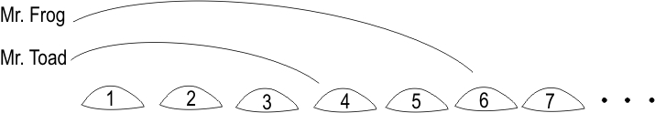
A. 3rd
B. 4th
C. 12th
D. 24th
Yesterday's Question | Class 5 | English
Sushmita wanted to arrange the following DVDs in ALPHABETICAL ORDER.
Choose the CORRECT option which arranges these DVDs in ALPHABETICAL ORDER.
A. 5 - 4 - 3 - 2 - 1 | B. 2 - 4 - 1 - 3 - 5
C. 1 - 2 - 5 - 3 - 4 | D. 4 - 2 - 1 - 5 - 3

Correct Answer : D

10th August
Class 5 | Science
Where among these will maximum topsoil erosion take place?
A. on a slope with thick vegetation cover
B. on a flat piece of land with no vegetation cover
C. on a flat piece of land with thick vegetation cover
D. on a slope with no vegetation cover
Yesterday's Question | Class 5 | Maths
Mr. Frog and Mr. Toad are sitting on a rock. There are many stones in front of them. Mr. Frog can jump 6 stones at a time and Mr. Toad can jump 4 stones at a time. Which is the first stone on which both of them will land, if they jump as far they can each time?
A. 3rd | B. 4th
C. 12th | D. 24th

Correct Answer : C

11th August
Class 5 | Maths
These are the two types of 'kadai' that a certain shop has.
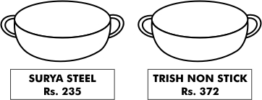
Shalini visits this shop and buys the steel kadai.
However, she changes her mind the next day and comes to take the non-stick one instead. She pays for the excess amount with a 500 rupee note. What amount should be returned to her?
A. Rs 363
B. Rs 265
C. Rs 137
D. Rs 128
Yesterday's Question | Class 5 | Science
Where among these will maximum topsoil erosion take place?
A. on a slope with thick vegetation cover | B. on a flat piece of land with no vegetation cover
C. on a flat piece of land with thick vegetation cover | D. on a slope with no vegetation cover

Correct Answer : D

12th August
Class 5 | Science
A power cut made Vishaka light candles. What form(s) of energy does a burning candle release?
A. Heat energy only
B. Light energy only
C. Chemical and sound energy.
D. Light and heat energy.
Yesterday's Question | Class 5 | Maths
These are the two types of 'kadai' that a certain shop has.
Shalini visits this shop and buys the steel kadai.
However, she changes her mind the next day and comes to take the non-stick one instead. She pays for the excess amount with a 500 rupee note. What amount should be returned to her?
A. Rs 363 | B. Rs 265
C. Rs 137 | D. Rs 128

Correct Answer : A

15th August
Class 5 | English

The dinosaurs lived on the earth millions of years ago. However, sceintistsare discovering fossils which give us signs of how they lived.

Choose the word which has been WRONGLY SPELT in the above sentences.
A. millions
B. sceintists
C. discovering
D. signs
Saturday's Question | Class 5 | Social Studies
When Early Man started living in houses, they were made of mud walls and had thatched roofs.
The figures shown below are of different types of houses that are found today. Identify the one that is closest to the house of an Early Man
A. 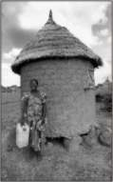 | B. 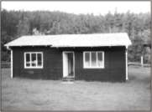
C. 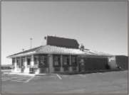 | D. 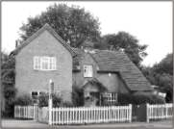

Correct Answer : A
16th August
Class 5 | Maths
100 x = 450
Which of these is true?
A. is equal to 4 | B. is less than 4
C. is between 4 and 5 | D. is greater than 5

Yesterday's Question | Class 5 | English

The dinosaurs lived on the earth millions of years ago. However, sceintistsare discovering fossils which give us signs of how they lived.

Choose the word which has been WRONGLY SPELT in the above sentences.

A. millions | B. sceintists
C. discovering | D. signs

Correct Answer : B

17th August
Class 5 | Science
Shown here is the picture of an umbrella. The function of the thin metal rods in the umbrella is similar to which 'organ system' of our body?
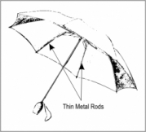
A. muscular system
B. skeletal system
C. respiratory system
D. digestive system
Yesterday's Question | Class 5 | Maths
100 x = 450
Which of these is true?
A. is equal to 4 | B. is less than 4
C. is between 4 and 5 | D. is greater than 5

Correct Answer : C
18th August
Class 5 | Maths
This is part of a biscuit packet wrapper. Which of these can be found out from the information on it?

A. The number of biscuits in this packet.
B. The price of each biscuit
C. The weight of each biscuit
D. The cost per kg of the biscuits
Yesterday's Question | Class 5 | Science
Shown here is the picture of an umbrella. The function of the thin metal rods in the umbrella is similar to which 'organ system' of our body?
A. muscular system | B. skeletal system
C. respiratory system | D. digestive system

Correct Answer : B
19th August
Class 5 | Science
Filtration using the equipment shown can be used to separate which of the following materials?
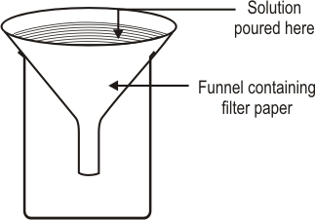
A. A solution of potassium permanganate and water.
B. A solution of salt and water
C. A mixture of sugar and sand.
D. A mixture of chilli powder and water.
Yesterday's Question | Class 5 | Maths
This is part of a biscuit packet wrapper. Which of these can be found out from the information on it?
A. The number of biscuits in this packet. | B. The price of each biscuit
C. The weight of each biscuit | D. The cost per kg of the biscuits

Correct Answer : D

22th August
Class 5 | English

william hanna and joseph barberas tom and jerry cartoon shows are very popular and i like tin cat of tomorrow the best

In which of the following is the given sentence punctuated correctly.
A. William Hanna and Joseph Barbera's Tom and Jerry cartoon shows are very popular and I like Tin Cat of Tomorrow the best.
B. William hanna and Joseph barberas' Tom and Jerry cartoon shows are very popular and I like Tin cat of Tomorrow the best.
C. William Hanna and Joseph Barbera's Tom And Jerry cartoon shows are very popular and I like Tin Cat Of Tomorrow the best.
D. William Hanna And Joseph Barberas' Tom and Jerry cartoon shows are very popular and I like Tin cat of tomorrow the best
Saturday's Question | Class 5 | Social Studies
The picture shows cranes in a very famous bird sanctuary, located close to the Taj Mahal in Agra, India. Which sanctuary is it?
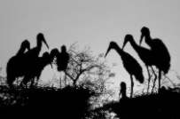
A. Kaziranga | B. Bharatpur
C. Kanha | D. Periyar

Correct Answer : B

23th August
Class 5 | Maths
Ramesh divided 3250 by 18 and got the Quotient 179 and Remainder 28. For this problem, which of these checks will help Ramesh find out his mistake?
A. Check if Quotient x Divisor + Remainder = Dividend
B. Check his calculations of 18 x 1, 18 x 7 and 18 x 9.
C. Check if Remainder < Dividend
D. Check if Remainder < Divisor
Yesterday's Question | Class 5 | English

william hanna and joseph barberas tom and jerry cartoon shows are very popular and i like tin cat of tomorrow the best

In which of the following is the given sentence punctuated correctly.

A. William Hanna and Joseph Barbera'sTom and Jerry cartoon shows are very popular and I like Tin Cat of Tomorrow the best. | B. William hanna and Joseph barberas'Tom and Jerry cartoon shows are very popular and I like Tin cat of Tomorrow the best.
C. William Hanna and Joseph Barbera'sTom And Jerry cartoon shows are very popular and I like Tin Cat Of Tomorrow the best. | D. William Hanna And Joseph Barberas'Tom and Jerry cartoon shows are very popular and I like Tin cat of tomorrow the best

Correct Answer : A

24th August
Class 5 | Science
The main reason electric wires are covered with plastic is:
A. Plastic is available in different colours.
B. Plastic is a good conductor of electricity.
C. Plastic is a poor conductor of electricity.
D. Plastic does not melt easily when heated.
Yesterday's Question | Class 5 | Maths
Ramesh divided 3250 by 18 and got the Quotient 179 and Remainder 28. For this problem, which of these checks will help Ramesh find out his mistake?
A. Check if Quotient x Divisor + Remainder = Dividend | B. Check his calculations of 18 x 1, 18 x 7 and 18 x 9.
C. Check if Remainder < Dividend | D. Check if Remainder < Divisor

Correct Answer : D

25th August
Class 5 | Maths
In which figure does the shaded part represent 0.3?
A. 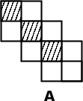 | B. 
C. 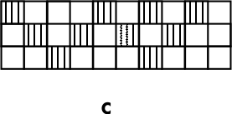 | D. 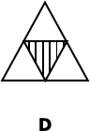

Yesterday's Question | Class 5 | Science
The main reason electric wires are covered with plastic is:
A. Plastic is available in different colours. | B. Plastic is a good conductor of electricity.
C. Plastic is a poor conductor of electricity. | D. Plastic does not melt easily when heated.

Correct Answer : C
26th August
Class 5 | Science
Which of the following skulls belongs to a horse?
A. 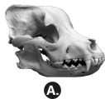 | B. 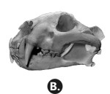
C. 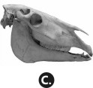 | D. 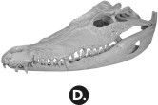

Yesterday's Question | Class 5 | Maths
In which figure does the shaded part represent 0.3?
A. | B.
C. | D.

Correct Answer : A

29th August
Class 5 | English

Our teacher told us to form a queue and walk into the class. She warned us not to ________ the line.

Choose the word OPPOSITE in MEANING to the UNDERLINED WORD to complete the given sentence.
A. change
B. repair
C. break
D. replace
Saturday's Question | Class 5 | Social Studies
The Government of Tamil Nadu wants to hold a tourism festival in Delhi to attract tourists to their state. Which of these events or displays can be used in the festival?
A. the performance of Kathakali dance | B. an exhibition of Kancheevaram saris
C. display of Buddhist paintings from Ajanta | D. promoting foods like dhokla and khaman

Correct Answer : B

30th August
Class 5 | Maths
What is 5 0?
A. 5 | B. 0
C. The same as 0 5 | D. Undefined or 'infinity'.

Yesterday's Question | Class 5 | English

Our teacher told us to form a queue and walk into the class. She warned us not to ________ the line.

Choose the word OPPOSITE in MEANING to the UNDERLINED WORD to complete the given sentence.

A. change | B. repair
C. break | D. replace

Correct Answer : C

31th August

Class 5 | Science
Fish have fins; in the same way, birds have _____
A. beaks
B. lungs
C. feathers
D. gills
Yesterday's Question | Class 5 | Maths
What is 5 0?
A. 5 | B. 0
C. The same as 0 5 | D. Undefined or 'infinity'.

Correct Answer : D

